Mental Health & Addiction Awareness Video
Worksheet
This worksheet has been created for teachers to use as a guideline to open up a discussion with students after viewing the video. Henry & Sally thank Lucy Cullen for creating this worksheet. Lucy is a ‘Gold Award winner for Oxfordshire County Council in 2020’ for all the work that she has done supporting young people who have been impacted by substance misuse.

- HOW DOES THE VIDEO MAKE YOU FEEL – discuss

Teacher – check for trigger warnings etc. close this question down with uplifting and positive areas of video – strong family bond, strong connections between mother and son, brothers.

- WHY DO PEOPLE DRINK ALCOHOL – let’s look at both the positive reasons and negative reasons?

Teacher – use a whiteboard to discuss, make two separate columns and discuss both options. Compare how many reasons for both. Are some the same – why?
Celebrations, cultural events, traditions, recreational experimentation, sporting events.

POSITIVE REASONS | NEGATIVE REASONS

WHAT ARE THE EFFECTS OF ALCOHOL USE ON THE HUMAN BODY?

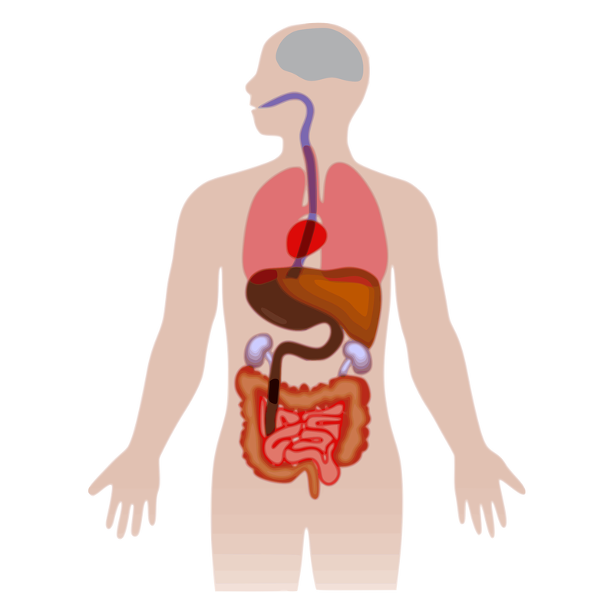
LONG TERM SHORT TERM
HEART SLURRED SPEECH
LIVER VISION DISTORTED
STOMACH
HANDS / FEET

Above are just a couple of examples. Discuss and add more effects to the long term and short term lists.

- Discuss with the students what Addiction is.

- WHAT DO YOU FEEL ARE THE FACTORS THAT CONTRIBUTE TO SOMEONE BECOMING ADDICTED TO ALCOHOL?

Possible answers – loss or grief, no motivation for change, poor mental health, environmental factors, genetics, financial loss, other addiction issues such as gambling, family breakdown, loss of control.

- WHAT SUPPORT DO YOU FEEL IS OUT THERE FOR PEOPLE WITH THIS ILLNESS?
Possible answers – Rehab, Alcohol Anonymous, seeing your local doctor.

- WHAT ARE THE BARRIERS TO PEOPLE GETTING SUPPORT WITH THEIR PROBLEMATIC ALCOHOL USE?

Possible answers -
Embarrassed, stigma, guilt, no capacity, no time, no idea how to get started, fear of failure.

- LET’S CREATE AN ACTION PLAN TOGETHER FOR SOMEONE WHO YOU FEEL NEEDS SUPPORT WITH THEIR ALCOHOL USE – what are the steps you would take to help them or yourself?

teacher - encourage them to do this at home too, like a promise to themselves.

Reach out

Be honest with yourself
Spot the signs
Call a friend
Tell a loved one
Tell a trusted adult create a support group

Show them you are listening

Be there for them
Know your own limits check in with yourself

